Disease Site:  Study Acronym: Sponsor:  Title:  For more info: [link to clinicaltrials.gov record] | Date Activated:  Date  PI:  Dr. Blank  Coordinator:  Name  Ext  Email  Pager
Brief Summary:

[Input brief summary]

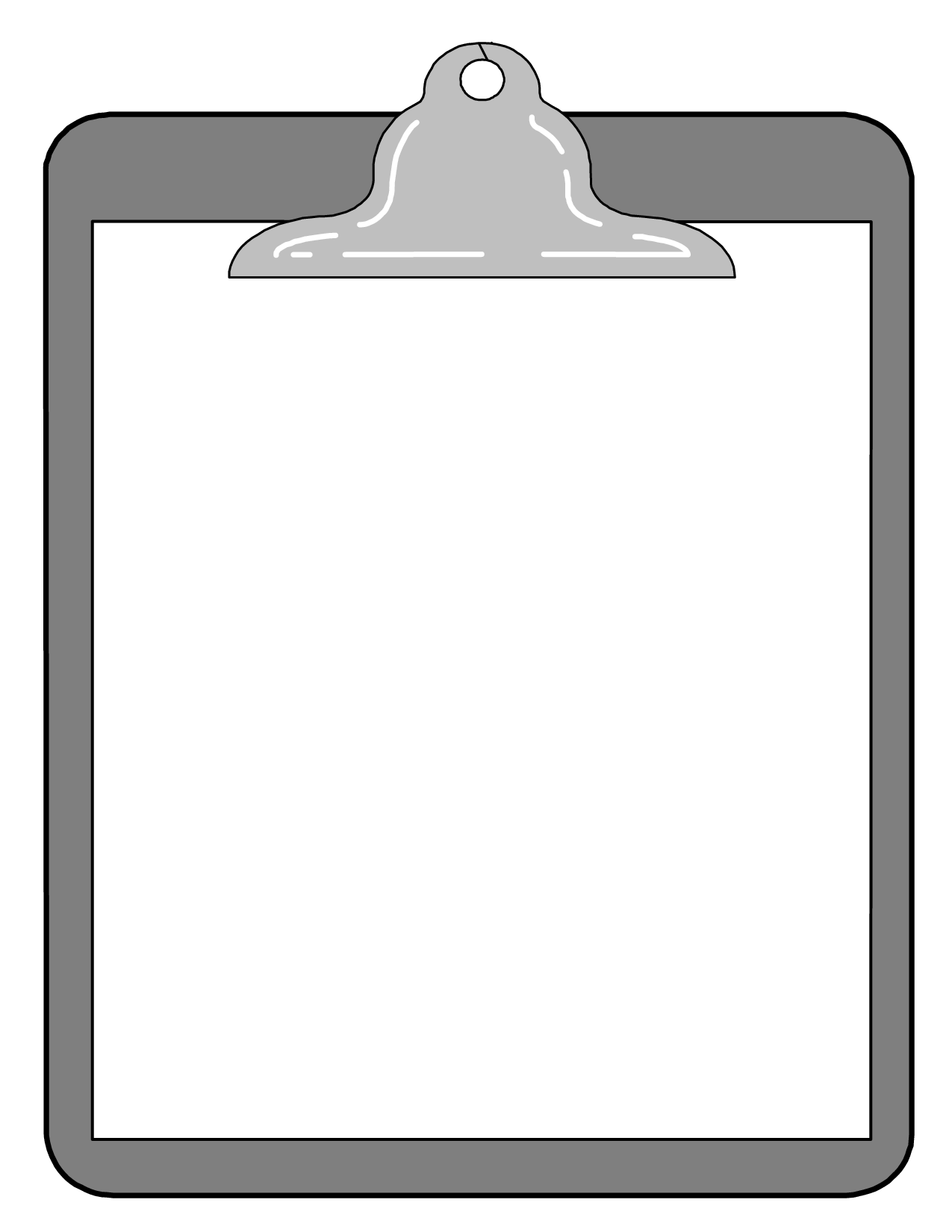
Main Inclusion Criteria:  - A  - B  - C  [Insert Study Schema] | Main Exclusion Criteria:  - D  - E  - F  - G  [Insert Study Outcomes]

