[Insert Logo] Clinical Trials Department
January 2016

Industry and Academic Trials
The balance between academic and industry trials is vital to the [institution name] growth as an academic teaching institution and leadership in cancer care. Currently, about 40% of our trials are industry and 60% are academic.

2015 Physician Recruitment
A crucial factor in trial recruitment is physician engagement in clinical trials as an important part of the care they provide to their patients. Congratulations to some of our top recruiters! The names below are above the 85th percentile of all recruitment!

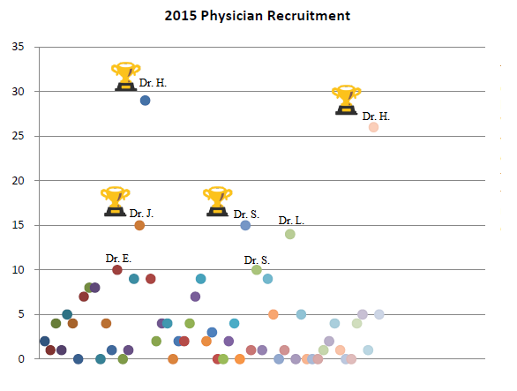
The Canadian Cancer Clinical Trials Network (3CTN)

The 3CTN is a pan-Canadian initiative to improve the efficiency and quality of clinical trials in Canada. The [NCC name] is a Network Cancer Centre linked with Affiliated Centres at [List NACCs]. 3CTN has connected the [NCC name] with multiple hospitals and cancer centres throughout Canada to improve patient access to academic clinical trials, address barriers to recruitment, bolster site performance, and re-vitalize the academic trial environment through national collaboration.
Next Steps for the Clinical Trials Department:
- A
- B
- C
- D
- E

[INSERT FOOTER]

A TOTAL OF
234 TRIALS

Recent Activations
These two studies activated at the end of 2015 and beginning of 2016 transcend DSTs as they focus on areas of disease that are common across many different disease sites.

HE.1
PI Name – CRC Name
Patients with painful liver cancer or liver metastases will be randomized to receive Best Supportive Care or Best Supportive Care plus 800 cGy of radiation therapy given in one fraction. Patients will conduct self-assessments regarding their pain and discomfort throughout the study at baseline, 30 days, and 90 days post radiation (or Best Supportive Care start date). This is a particularly exciting study since radiation is not typically given for painful liver lesions.

SC.24
PI Name – CRC Name
This is a feasibility study to determine whether physicians and patients are willing to participate in a study comparing Stereotactic Body Radiotherapy (SBRT) versus Conventional Palliative Radiotherapy (CRT) for spinal metastases. There is evidence suggesting that SBRT may improve treatment for patients with spine metastases. Patients will be randomized to receive either CRT (20 Gy in 5 fractions) or SBRT (24 Gy in 2 fractions). Pain and analgesic assessments will be recorded via patient diaries and questionnaires for 6 months post radiotherapy.

