How to submit a Portfolio application in EDGE to 3CTN Coordinating Centre (3CTN CC)
Note: These instructions are for the user who has an EDGE account. The EDGE user can complete the Portfolio application and submit to the 3CTN CC, so the application can be reviewed within EDGE.

The application submission process is very similar to “add a project”. Before completing the application form, it is good practice to search Global Projects to ensure the study has not already been added by another organization. We are planning to have a few common sponsor to submit the trials on behalf of the sites, you can wait for them (e.g. CCCTG) to do the submission.

If the study has been added by another organization, please click “request involvement” and coordinate with the other organization regarding who should lead the submission.

If the study is not found in EDGE, you can submit the application by “add a new project”.

To add a new project to EDGE, click the Management tab at the top.

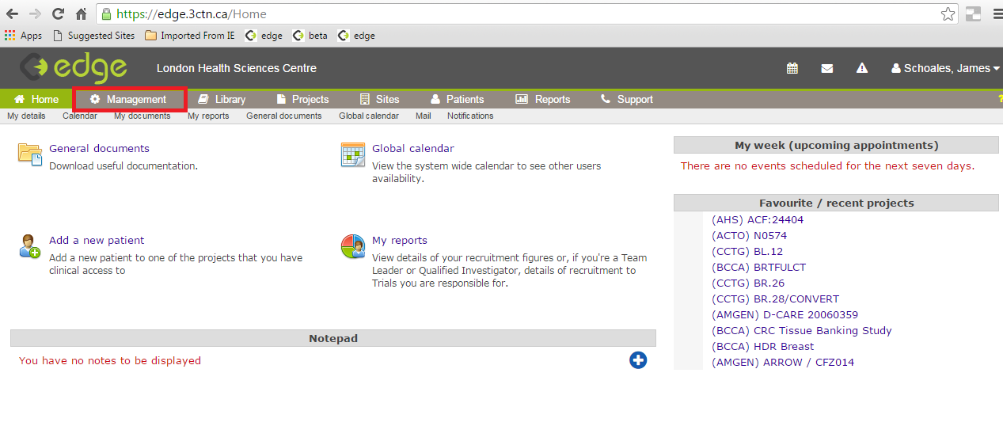

Click on the Projects icon.

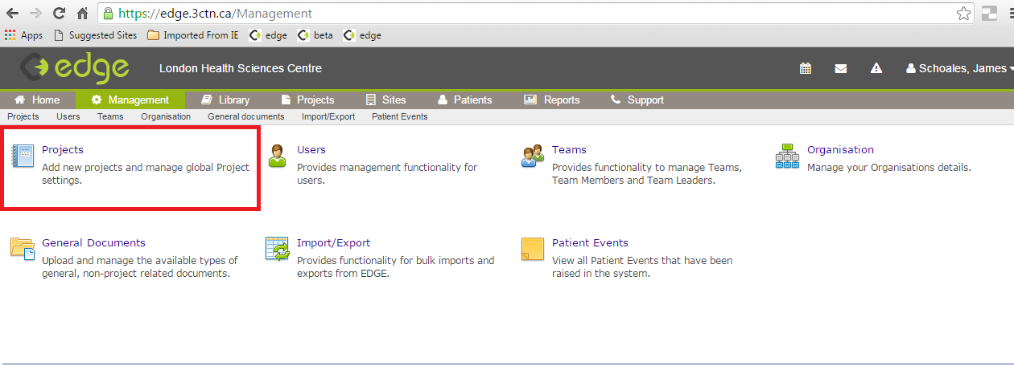

Click on the Add a new project icon.
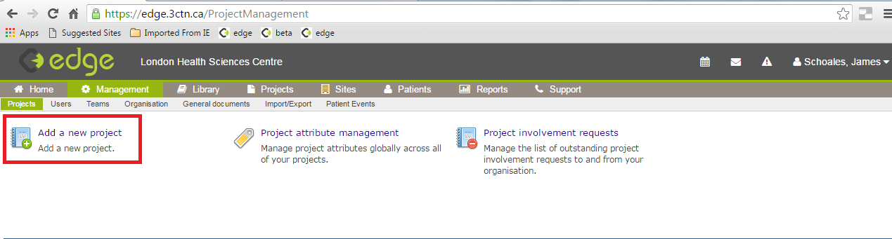

When adding a new project you will be prompted to complete the core details of the study. This will include short and long trial titles as well as selecting a Study Chair from the list of users on EDGE. When adding a project, ensure you are working from the most recent copy of the Protocol regarding your study to complete all the information. All the information needed can be found on clinicaltrials.gov or the trial protocol.

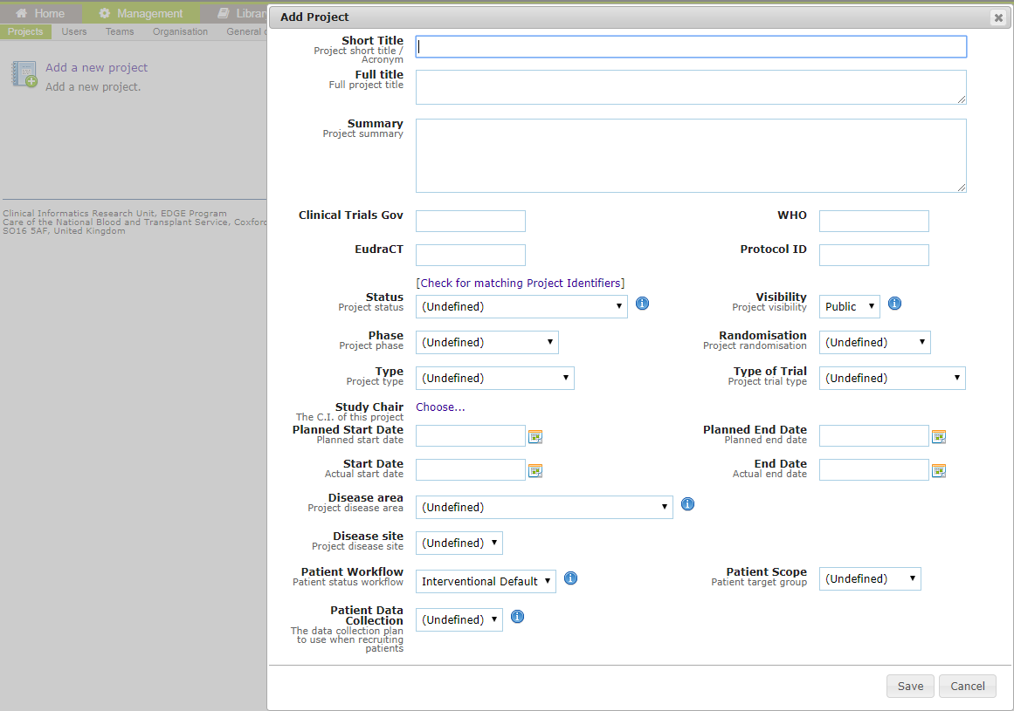

Title= short form of sponsor in () and protocol number Ex. (CCTG) IND.235
Full title= full title of trial
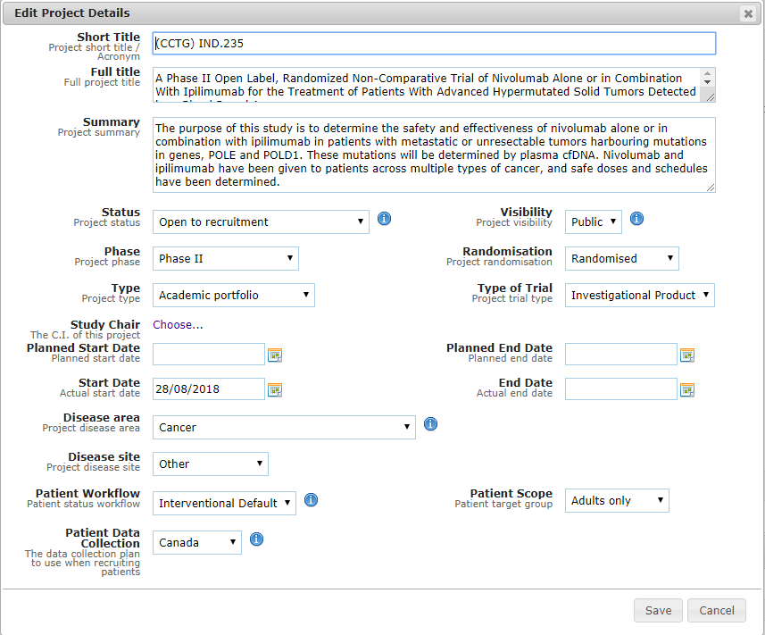

At a minimum, add the following information highlighted in red:
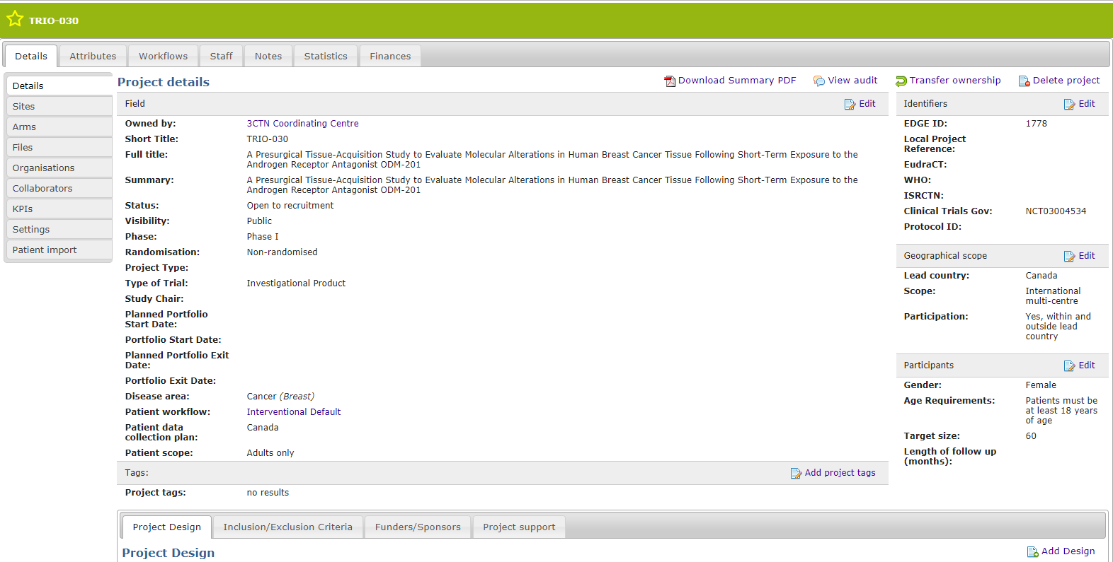

Once all the project details are completed, please go to “attribute” to add “3CTN Portfolio Application Form” with as much information as needed.
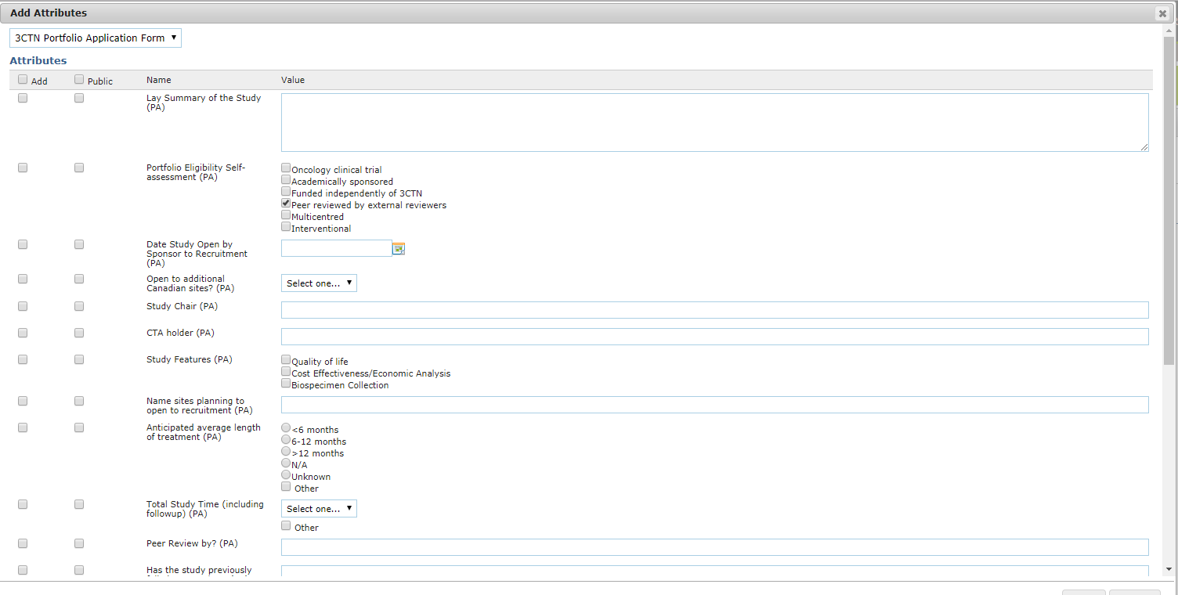

If you don’t have all the information for the trials, please talk to the sponsor or other sites who are involved in the same trial to complete the outstanding information.

The following are the “submission” steps:

Once all the information is entered, please add “3CTN Coordinating Centre” under “organization”

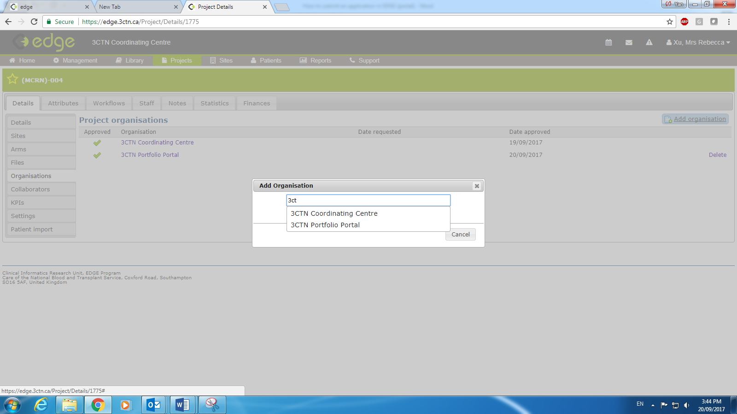

Then go to project detail page to transfer the page ownership to “3CTN Coordinating Centre”

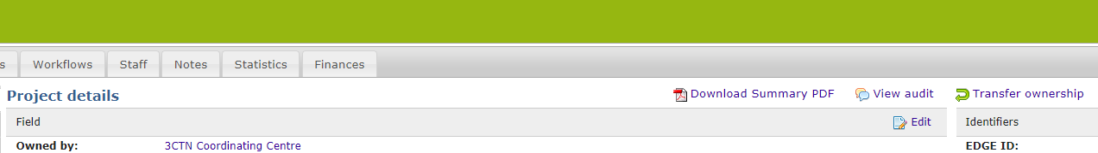

3CTN CC team will be notified that you submitted a trial for assessment.

Similar to before, once the trial is approved, 3CTN CC will email the notification to the sites.

