3CTN Portfolio User Search Guide

- Purpose
The purpose of the 3CTN Portfolio Search Page is to allow users to view and search for actively open and recruiting studies or recently closed studies included in the 3CTN Portfolio.
- Overview
The 3CTN Portfolio Search Page is open access and does not require a login. It is available at:
- www.3ctn.ca/page/portfolio or Portfolio section on the 3CTN website (http://www.3CTN.ca);
- Click the Search the 3CTN Portfolio button.

In the 3CTN Portfolio, studies are categorized using a three-tier classification: cancer →disease site→specific disease types. The Portfolio Search is for academic cancer trials only, so please make sure “cancer” is selected before searching “disease site”.

The initial page of the Portfolio will only display the search box shown in Figure 1. The bottom of the page is reserved for search results and will be automatically populated once the search criteria is entered.

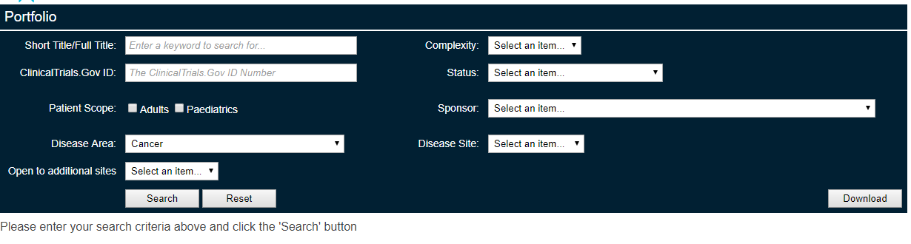
Search button

Figure 1. Portfolio search box
The search box should enable you to find the relevant studies matching your criteria. To view the complete listing of Portfolio trials, click the “search” button without setting a search criteria. The Portfolio list will be displayed as below.
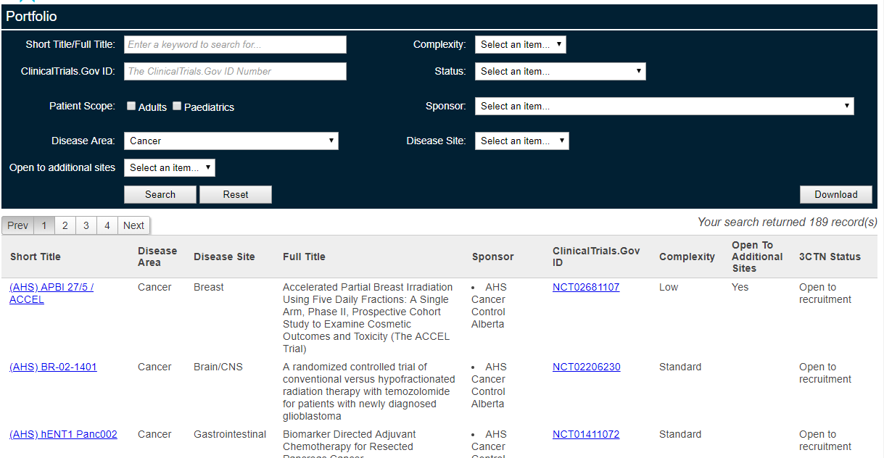

Search Results
Figure 2. Portfolio search results
- Search Criteria
The Portfolio can be searched by using keywords of the short title/full title, the assigned clinicaltrials.gov ID number, disease sites, patient scope, status and sponsor. Definitions are listed in Appendix A. You can download the search results to Excel for further analysis.
  - Dropdown Lists: Search by Disease Site
The search engine is defaulted to cancer. Clicking on the disease site in the search box will return a list of trials in different disease site.
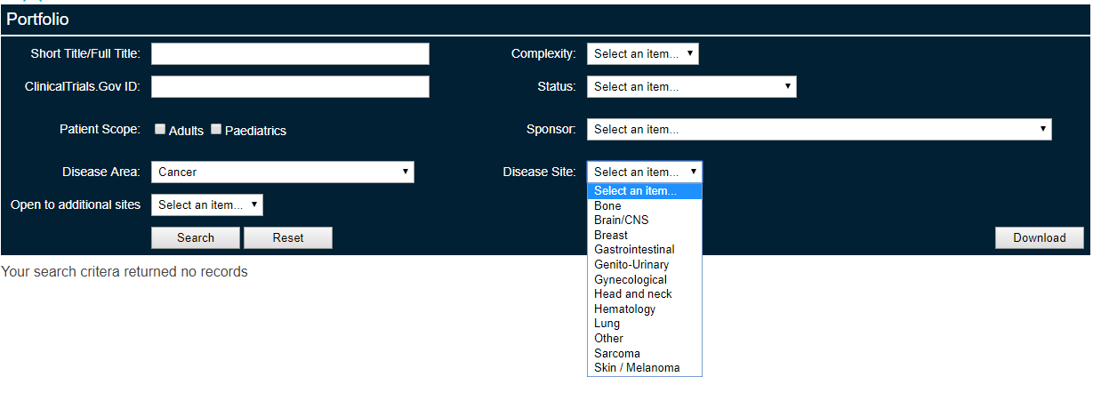
  - Text Fields: Search by Title and ClinicalTrials.gov Number
Search by entering the keywords of the title and/or clinicaltrials.gov number. The following is an example:
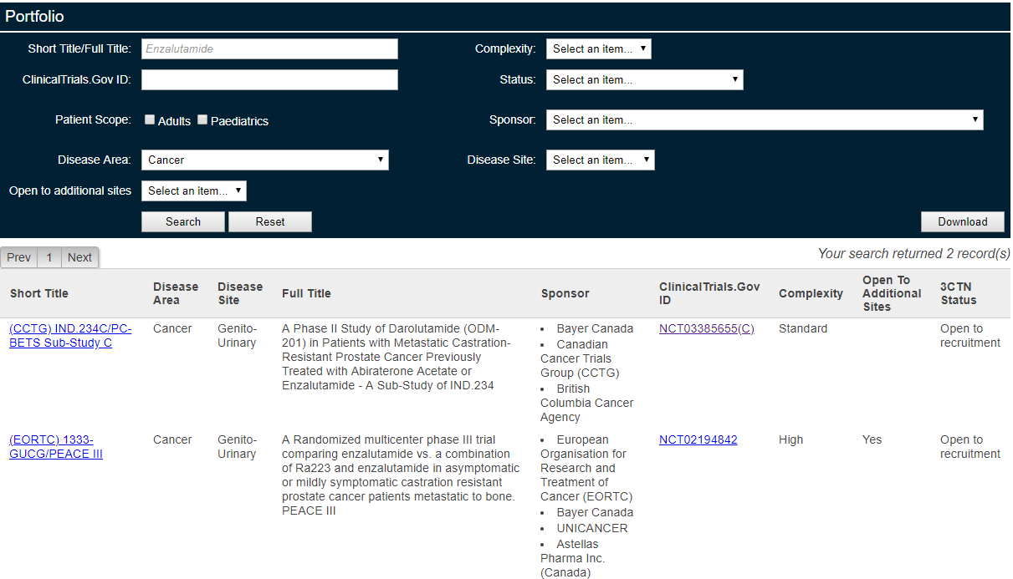

  - Dropdown Lists: Search by Patient Scope
Select the patient scope - you can filter the list by Paediatric patients only, Adult patients only or both Paediatric and Adult patients.
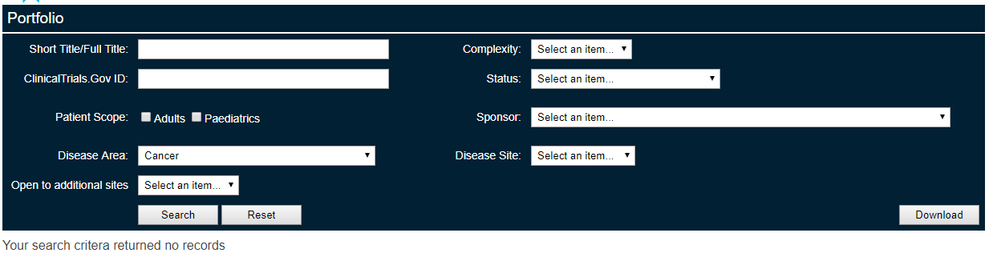
  - Dropdown Lists: Search by Status and Sponsors
Clicking on the status in the search box will return a list of trials in different stages.
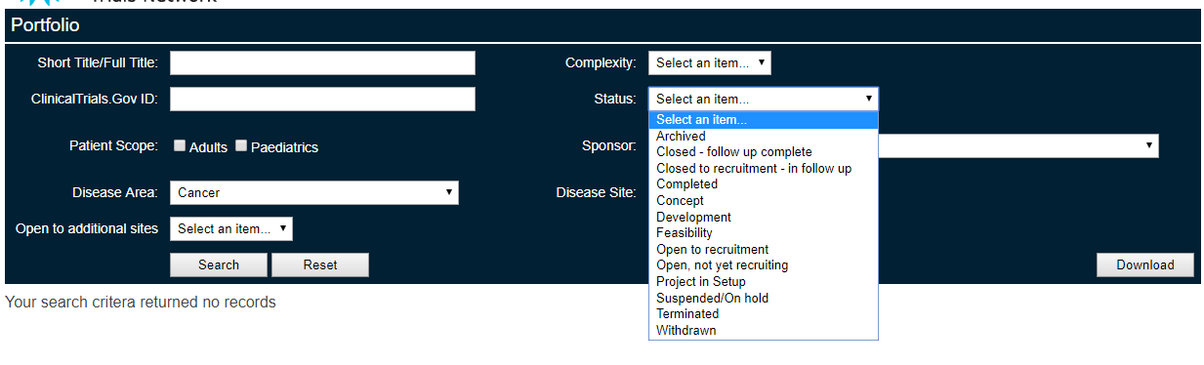
You can filter the list with your selection. For the definitions of the different statuses, please refer to Appendix A.
- Search Results
There are two hyperlinks in the search results that can give you more details.
  - Title linked to project details
Clicking a specific trial title will open a “project details” page shown below:
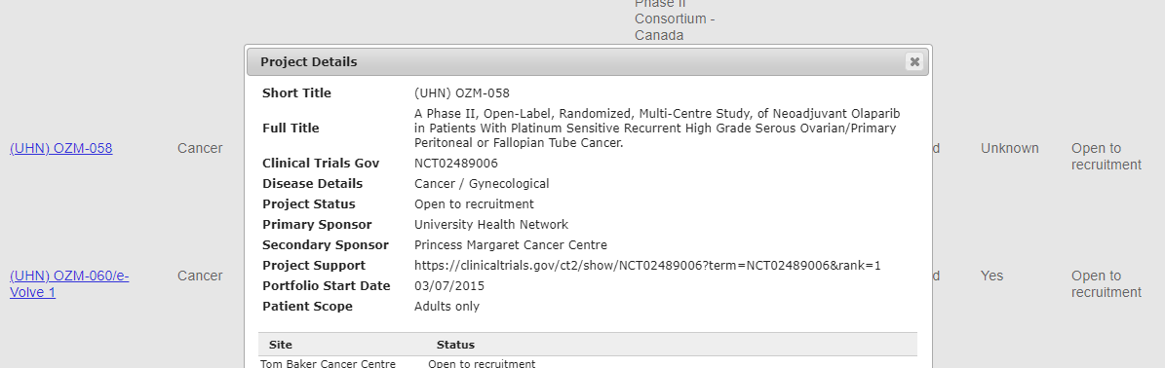
  - Website linked to clinicaltrials.gov
Clicking “ClinicalTrials.Gov ID” will open the clinicaltrials.gov information in a new tab.
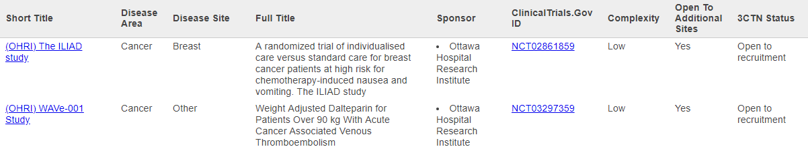
- Contact Information
3CTN is dedicated to making it more user-friendly. All feedback is welcomed at info@3ctn.ca.
A trial is eligible for the Portfolio if it meets the Portfolio Eligibility Criteria. To apply for Portfolio status, complete the Network Portfolio Application Form and submit to info@3ctn.ca for review and approval by 3CTN and the Portfolio Committee.

Appendix A: Terms and Definitions
Project: It is equivalent to a “trial”. In this Portfolio, it is usually an academic cancer clinical trial.

Title: It is usually the Sponsor Initials plus Sponsor Protocol ID.

Sponsor: List of Sponsors for the project. Project may have more than one sponsor. The primary sponsor is usually the holder of the Clinical Trials Application (CTA).

Status:

- Concept: The study is in its conceptual phase and no development work has started.
- Development: The study protocol is currently in development and no submission has been made.
- Feasibility: The proposed study is undergoing an evaluation to access its potential.
- Project in set up: The study is currently undergoing ethics or governance approval.
- Withdrawn: The sponsor has withdrawn the study to site participation prior to enrolment of the first subject.
- Open, but not recruiting: The sponsor has opened the study for site participation, but no site is yet open to recruitment.
- Open to recruitment: The study sponsor has opened the study to recruitment.
- Suspended: The study sponsor has suspended subject enrolment for interim analysis, but may start again.
- Terminated: The study sponsor has prematurely stopped the study before completion.
- Closed to recruitment – in follow up: The study site has reached target or is no longer recruiting patients. All recruited patients have now completed treatment and are in the process of standard follow up.
- Closed –Follow Up Complete: The study is closed to recruitment. All patients have completed the standard follow up and have been discharged.
- Completed: The study has ended normally and is closed all activities. All participants are off-study (that is, the “last subject”, “last visit” has occurred).
- Archived: The historical records for the study have been accumulated and have been stored.

